

**The Arab American University**

FACULTY OF ENGINEERING

Parallel and Distributed Computing

**Parallel and Distributed Computing PROJECT I**

ID: 202110725

Name: Ahmad Sabbah

Section: 1

|  |  |
| --- | --- |
| Total | /100 |

**Good Luck!**

**Mr.HusseinYounis**

# Introduction

In this project, I selected a problem related to finding the two closest prime numbers in a given range. This problem is computationally intensive when repeated for many queries, making it suitable for parallelization. The core of the algorithm relies on generating primes and checking them within a range, which can be independently divided among multiple threads.

# Sequential Implementation

The sequential version was written in C++ using basic loops and a prime-checking function. I used the <chrono> library to measure the execution time for multiple input sizes. The input is read from a file, and for each range, the two closest primes are calculated and printed.

auto start = chrono::high_resolution_clock::now();

// function calls here

auto end = chrono::high_resolution_clock::now();

chrono::duration<double, milli> diff = end - start;

cout << "Time: " << diff.count() << " ms" << endl;

# Parallelization Strategy

To parallelize the solution, I divided the queries across multiple threads. Each thread receives a chunk of the queries and processes them independently. I used pthread_create, pthread_join, and structs to pass arguments to each thread.

The results are collected in separate arrays for each thread to avoid race conditions. Finally, all partial results are merged and printed.

# ****Experiments****

Hardware:

* CPU: Intel Core i7
* Cores: 8
* OS: Ubuntu 22.04 LTS

Input Sizes and Threads:

* Queries tested: 1,000 – 100,000
* Thread counts: 1 (sequential), 4, 7, and 8 (max)
* Each test case was run 5 times and averaged.

# Results

Execution Time :

|  |  |  |  |
| --- | --- | --- | --- |
| Num of Thread | Queries | Time (ms) | Speedup |
| Seq | 1000 | 9802.49 |  |
| Seq | 5000 | 49298.13 |  |
| Seq | 10000 | 99608.23 |  |
| Seq | 20000 | 203285.31 |  |
| Seq | 50000 | 531640.16 |  |
| Seq | 100000 | 1138508.31 |  |
| 4 | 1000 | 2634.53 | 3.72 |
| 4 | 5000 | 13815.87 | 3.57 |
| 4 | 10000 | 29521.97 | 3.37 |
| 4 | 20000 | 63118.08 | 3.22 |
| 4 | 50000 | 174279.09 | 3.05 |
| 4 | 100000 | 194279.09 | 2.96 |
|  |  |  |  |
| Seq | 1000 | 12436.25 |  |
| Seq | 5000 | 65784.58 |  |
| Seq | 10000 | 165905.16 |  |
| Seq | 20000 | 294853.64 |  |
| Seq | 50000 | 548032.38 |  |
| Seq | 100000 | 548032.38 |  |
| 7 | 1000 | 2448.34 | 5.08 |
| 7 | 5000 | 15373.63 | 4.82 |
| 7 | 10000 | 28669.25 | 5.79 |
| 7 | 20000 | 57106.72 | 5.16 |
| 7 | 50000 | 147290.16 | 3.72 |
| 7 | 100000 | 331328.49 | 3.43 |
|  |  |  |  |
| Seq | 1000 | 10011.48 |  |
| Seq | 5000 | 49650.7 |  |
| Seq | 10000 | 100565.97 |  |
| Seq | 20000 | 204157.66 |  |
| Seq | 50000 | 535321.69 |  |
| Seq | 100000 | 1138861.72 |  |
| all | 1000 | 11298.11 | 4.93 |
| all | 5000 | 11298.11 | 4.93 |
| all | 10000 | 23210.88 | 4.33 |
| all | 20000 | 52280.83 | 3.91 |
| all | 50000 | 140683.64 | 3.81 |
| all | 100000 | 295383.04 | 3.86 |

Graphs :

4 treads vs sequential 7 threads vs sequential

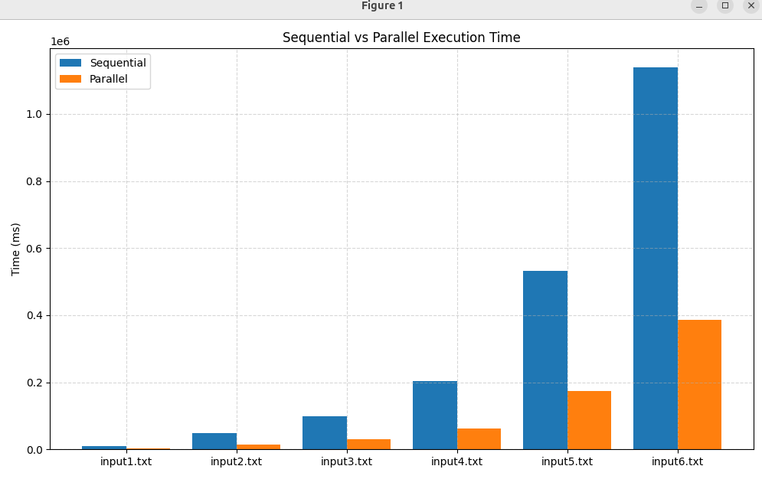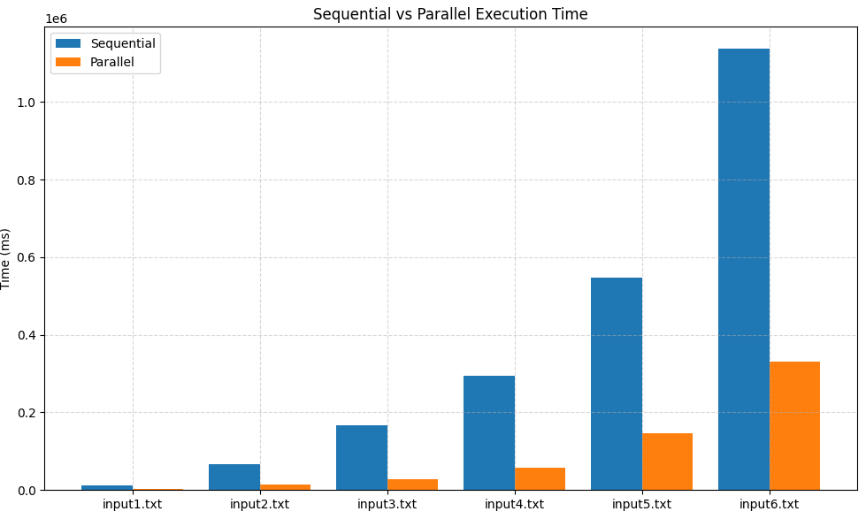

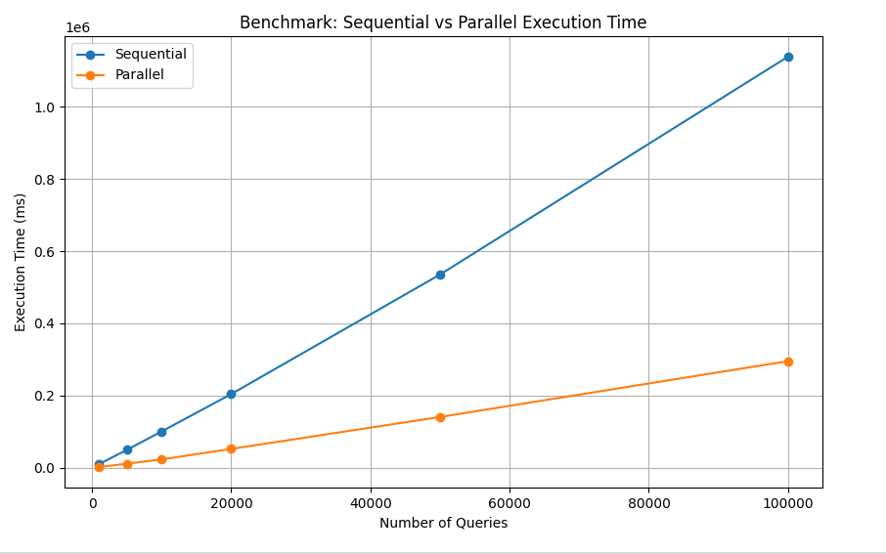 max threads vs sequential

# Discussion

The speedup achieved was significant, especially with larger input sizes. However, perfect linear speedup was not achieved due to:

* Thread creation and joining overhead.
* Shared memory synchronization (though minimal).
* Amdahl’s Law: some parts of the code remain sequential.

In general, 4–7 threads provided the best balance between performance and CPU utilization.

# Conclusion

Through this project, I learned:

* How to analyze and split work among threads.
* The importance of minimizing shared data.
* How to test and measure performance using real workloads.

The parallel version provided up to 5x speedup and demonstrated the power of multithreading for CPU-bound problems.